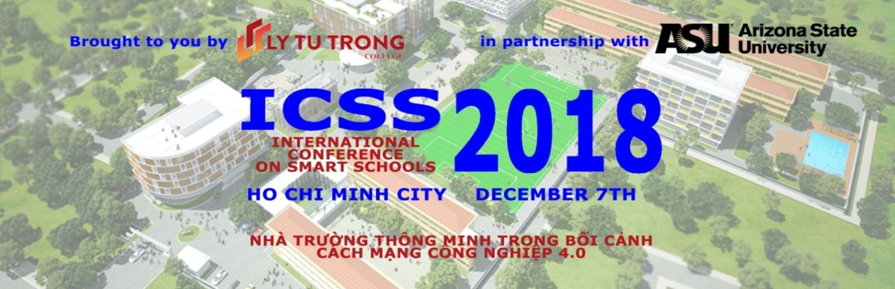
December 7th, 2018
Dear Conference participants,

On behalf of Ly Tu Trong College of Ho Chi Minh City, we would like to sincerrely thank you for your important participation in, and contribution of ideas and experiences to the International Conference on Smart Schools 2018 in the Context of the 4th Industrial Revolution (ICSS), held on December 7, 2018, in Ho Chi Minh City.
We hope that you have found the conference informative and useful. The lessons learned from of other countries that have been pioneering in IT and education have helped us recognize challenges and opportunities as well as its impacts on vocational education brought by revolution industry 4.0.
We would like to express our sincerest appreciation to our co-organier, partners, sponsors, scientists, experts, educators, industries and businesses for your invaluable support throughout our preparation for the Conference. Should there be any oversight during the Conference, we send you our sincere apologies.
We do hope that in the future, we will receve your continuous support, sponsorship, participation, and comments as we work towards building Ly Tu Trong College of Ho Chi Minh City to become a smart school, contributing towards the development of vocational education and of our nation in the context of industrial revolution 4.0.
On behalf of the Conference Organizers, we sincerely wish you excellent health, happiness and success!

RECTOR
PHAM HUU LOC

